MONTHLY EXPENSES CALCULATOR
Felix, the secretary of Gandhinagar colony association - decides to arrange for Music and Karate lessons to the colony children. He wants the count of children who will be taking up Music and Karate lessons every month, so that he can provide fund for their needs. The colony has a head, who will place fund-request to the colony-association. Create a web page - which will allow this colony head to calculate the monthly expense before placing request for fund. The monthly expense calculated must be displayed on the same page as shown in the screen shots given below.

Plain web page design :

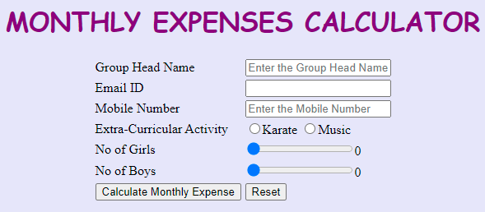
Web page after entering valid details and clicking on “Calculate Monthly Expense” button :
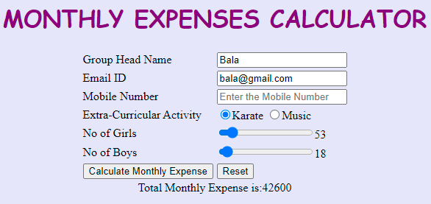

Use the Label Name and the Input Component Id as given. The Component Id can be given in any case (Upper case or Lower case or Mixed case). All the necessary attributes for the Components should be given. The Component Id should be specified for each HTML Component. If the Component Id is not provided for an HTML component, marks will not be provided for that component. All Tags, Elements and Attributes should conform to HTML5 Standards.

Provide the details as given in the table below.
Req. # | Req. Name | Req. Description
1 | Design an HTML page for “MONTHLY EXPENSES CALCULATOR” application | Note: The text highlighted in bold in the Description needs to be implemented in the code to complete the web page design.
  Label Name | Component Name  (Specify it for the “name” attribute) | Description
  Group Head Name | groupHeadName | To enter the name of the group head.  Design Constraints:  - The text “Enter the Group Head Name” should appear by default.  - It should be mandatory.  - Use type=“text” with pattern attribute to accept the alphabets and space only.
  EMail ID | groupHeadEmail | To enter the email id of the group head.  Design Constraints:  - It should be mandatory.  - Use type=“email”.
  Mobile Number | groupHeadMobileNumber | To enter the mobile number of the group head.  Design Constraints:  - The text “Enter the Mobile Number” should appear by default.  - It should be mandatory.  - Use type=“text” with pattern attribute to accept the 10 digit mobile number to start with either one of the following numbers: 7,8 or 9
  Extra-Curricular Activity | curricularActivity | To Select the activity.  Design Constraints  Use Radio Button and its values should be 'Karate' and 'Music'.  The field is mandatory.  (set required on both)
  No of Girls | noOfGirls | To select the number of girls.  Design Constraints:  Provide the correct input type to make this component a range slider with min value 0 and max value 500.  For this component set id attribute value as ‘girlseval’  It should be mandatory.
  No of Boys | noOfBoys | To select the number of boys.  Design Constraints:  Provide the correct input type to make this component a range slider with min value 0 and max value 500.  For this component set id attribute value as ‘boyseval’.  It should be mandatory.
   | submit | Submit Button to submit the form  Design Constraints  - The input type should be “submit”.  - Value should be “Calculate Monthly Expense”
   | reset | On clicking this button, all fields should be reset. Value should be “Reset”
2 | Apply the mentioned styles using CSS to the components | STYLING WITH ELEMENT SELECTORS  - Body backgroud color should be “#E6E6FA”  - The heading "MONTHLY EXPENSES CALCULATOR" should be done using <h1> tag the text color should be “#800080”, font family should be “cursive” and it should be aligned to center of the webpage.  - Extra-Curricular Activity and Amount should be displayed as the table header(th) with the back ground color as “#00FFFF”  Note: Fill in the style tag so as to have the given styles applied to the components. (Do not use Inline CSS)
3 | Use JavaScript for displaying the total monthly expense. | Use JavaScript for displaying the total monthlyexpense:  When the valid values are entered and the button component is clicked, the total monthly amount should be displayed as follows:  Total Monthly Expenses is: totalMonthlyAmount  in a div tag with id as “result”.  Total Monthly Amount is calculated using the below formula:  (No of Girls + No of Boys) * 600 - if the extracurricular activity opted is Karate  Or  (No of Girls + No of Boys) * 500 - if the extracurricular activity opted is Music  Note:  - Use getElementsByName() or getElementById() function to retrieve the values.  - Please do not use “let”. Instead, use “var”.
4 | form tag with attribute onsubmit | form tag is already given in the code template. Do not change the code template and do the coding as per the requirements and specification.  Make sure that the onsubmit attribute in the form tag invokes the JavaScript function like "return calculateExpenses()".  Also ensure that “return false;” statement should be the last line of the JavaScript function “calculateExpenses()”.

